Energy Modelling Platform – Nigeria (EMP-N) | 2025
Concept Note

Context
Secure, adequate, and reliable access to modern energy forms and services for livelihoods and industrialisation is critical for attaining Africa’s sustainable and inclusive development transformation, framed by the African Union’s Agenda 2063 and the UN 2030 Agenda for Sustainable Development. This will simultaneously bring about resilience to shocks posed by climate change.
Against a background of increased energy demand for structural transformation, a rising population, the need for sustainable livelihoods, and the adverse impacts of climate change on the continent, there is an urgent need to support African countries to strengthen their capacities in energy planning. This will optimise investments in energy production and services to take advantage of the continent’s abundant renewable energy resources, falling technology prices, and increasing availability of free open-source and robust energy planning models, data, and interfaces for customised applications to the needs of each country.
Furthermore, almost all African countries have included renewable power generation in their Nationally Determined Contributions (NDCs) to climate action under the Paris Agreement on climate change framework. The prominence of renewable energy in these actions, coupled with Africa’s abundant renewable energy resources (including variable renewable energy sources such as wind and solar) and the urgent need to mobilise investments to meet a considerable energy deficit on the continent, requires strategic assessment planning. This is needed to ensure (i) enough generation capacity and expansion of supply to meet demand, (ii) system flexibility to accommodate high shares of renewables, (iii) adequate transmission capacity to dispatch power to demand centres, (iv) grid stability to accommodate short time frame variations, (v) appropriate and effective off-grid systems, (vi) optimised investments that capitalise on falling costs of low-carbon technologies to minimise the risk of stranded underperforming energy infrastructure assets in the future, and (vii) sustainable and coordinated use of energy, land, and water resources. Climate action has gained even more credence in light of the ongoing energy transition and growing calls for Africa to define net-zero emission targets. Yet, much of Africa has a considerable deficit in human and institutional capacity regarding effectively using models and modelling tools for energy supply, demand, and investment planning and management.
To date, CCG has held 12 regional EMPs, training over 700 participants. EMP-N is the first instance of a country specific EMP and the beginning of a new wave of EMP, which will provide skills and knowledge in open-source modelling tools for a specific country audience. EMP-N 2025 will take place from 6 October to 17 October at the National Open University of Nigeria in Abuja, Nigeria.

Objective

The EMP-N’s overarching objectives are to:
- Gather the energy planning and modelling community in Nigeria to share experiences, models, and data in climate, land, energy, and water systems.
- Support human and institutional capacity in Nigeria for integrated energy modelling and investment planning.
- Support the development of centres of excellence for energy planning in Nigeria.
- Promote efficient and widespread use of open-source modelling tools to support the implementation of the SDGs, the Paris Agreement, and Africa’s Agenda 2063.

Structure of the EMP-N 2025
EMP-N will be held in person.
The application period is as follows, please make note of the dates below:
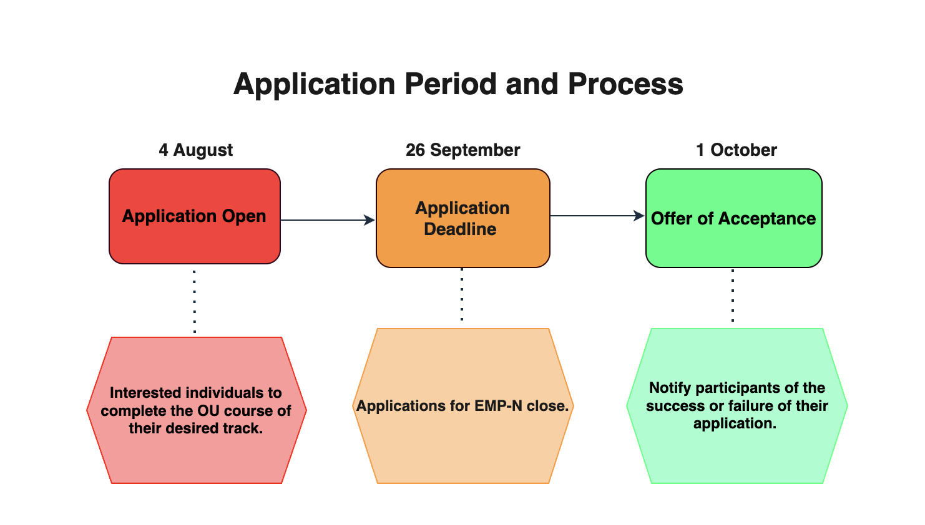
The application period will shortly be followed by the training period, see below for dates and details.
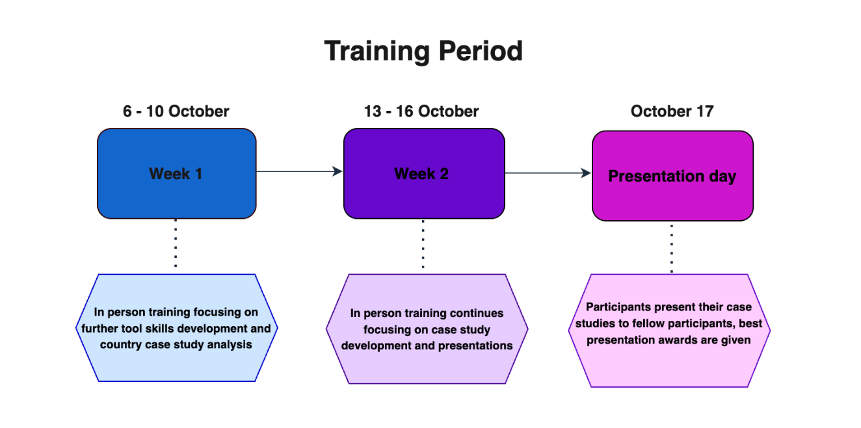

During the EMP-N 2025, participants will acquire energy and resource modelling skills using one of the following open-source modelling tools for sustainable development pathways under leading academics and researchers in the field of model-informed development strategies. There are nine tracks. They will focus on either.

OnSSET / The Global Electrification Platform [Link]
This course will help participants learn about geospatial energy modelling, how to build your own electrification analysis, how to include the geospatial dimension in your energy modelling to unlock new dimensions and gain an understanding of the earth’s different energy resources, and how to incorporate them in your energy modelling.
- MAED [Link]
This course will teach participants how to use two of the International Atomic Energy Agency (IAEA) modelling tools: the Model for Analysis of Energy Demand (MAED) and the Energy Balance Studio (in the process, participants will learn about energy balances and energy systems in general, assisting them in energy system planning).

Introduction to CLEWS: Climate, Land-Use, Energy and Water Systems [Link]
This course will teach participants how to analyse policy decisions on issues such as the promotion of clean energy, competition for water and agricultural modernisation by teaching how to define model components, linking them together in an integrated system representation, populating the model with data, running a model, and interpreting results using CLEWS.

Energy Access Explorer: A Data-driven, Integrated and Inclusive Approach to Planning for Achieving Universal Access to Energy for Equitable Development [Link]
EAE will introduce the importance of spatial data and analytics for providing actionable insights regarding the expansion of clean energy services for socio-economic development. Participants will work on practical hands-on activities to identify high priority areas for energy access interventions. That is, through the front-end of the application. They will also be introduced to and work on the backend infrastructure (through the user-friendly interface of the dynamic information system) to develop an EAE application for a given geography of interest.
- Geospatial Data Management for Energy Access Modelling and Planning [Link]

Participants will be introduced to geospatial data and analytics as a critical tool for electrification planning and infrastructure development. Through practical, hands-on sessions, they will explore how to visualise and analyse demographic, economic, and spatial data to identify energy demand, resource availability, and optimal infrastructure pathways. Using open data sources and state-of-the-art tools, they will learn how to collect, manage, and document geospatial datasets to support modelling efforts and ensure replicability. The course will guide them through both front-end use of geospatial platforms and backend processes such as spatial data infrastructure and data curation, empowering energy planners and technical stakeholders to align with the sector’s digital transformation.

Each course has two parts:
- Self-paced study: Participants will complete the track of their choice and attach the certificate of completion on their application form.
- In-depth hands-on training: In-person interactive training with dedicated trainers*. The coaching will help you develop a national case study, which you will then present as an ‘elevator pitch’ to a senior decision-maker.

Participants will receive a certificate on successful completion of the training, once they provide their presentations (PPT uploaded to Zenodo – details will be provided at a later stage).

The last day of the EMP (17 October) will be a presentation day, where participants will present their case studies to fellow participants.

Application
There is no fee to attend; however, attendance to EMP-N is at your own cost, with only lunch being provided at the venue of the training. Nigerian candidates will be prioritised; however, international applications are also welcome.
Applicants interested in participating in the EMP-N are required to complete the application form with the attached using the link below:
https://loughboro.qualtrics.com/jfe/form/SV_1KN3d6igOqNSw5M
This form has a ‘Personal Details’ section and an ‘Application’ section, where candidates are required to share information such as, but not limited to, their current job responsibilities, motivation for the application, and field of interest. Such writing from the candidate will subsequently be taken into consideration for the application process.
- In order to be considered, you must attach the Open University certificate of completion for your chosen track to your application.
- Additionally, candidates are required to complete the ‘Modelling, policy and political economy’ course available on the Open University website, and attach the certificate of completion on the application form.
- Furthermore, a stamped Letter of Commitment stipulating an express statement from participants’ respective institutions towards attendance of the module of choice is also mandatory for attendance. Please do not mention your personal details (Name, Company/Organization, Email Address, Mobile Telephone); the letter should only include the details of the individual signing the letter. To apply, you will have to demonstrate:
- That the output of your study is in demand by the government that you represent; or
- That the skills, tools, and teaching material that you acquire will be used in university teaching or government planning knowledge management; or
- That the output will fit into policy-relevant research to be published on a visible platform.
Supporting documentation will require a letter from a head of unit or higher (government) or head of department or higher (university and others). Exceptions will be made for selected candidates from participating organisations and ongoing technical assistance programmes, and applicants will be notified via those channels. Priority will be given to participants from countries with a demonstrated need and ability to apply the training to policy development. The selection of participants will include considerations of equity, diversity, and inclusion.
In completing the application, you will also be required to submit a Letter of Motivation via the application form, in which the you state why you should be selected for the course, and how your background knowledge and experience makes you an ideal candidate (1,200 characters). Please ensure to exclude any personal data in the Motivation letter.
The deadline to submit the application form for participants who wish to attend in person is at 12.00 pm (GMT) on 26 September. If unsuccessful, applicants may still be considered for online participation. It should be noted that spaces are limited and the application process is highly competitive.
Furthermore, full-time commitment towards the EMP-N is crucial.

IT requirements
Note that participants will require a computer with stable internet access to participate in the training. It is recommended, for all tracks, that participants have at least 8 GB of RAM and a relatively new computer. Specific Tracks have additional computer requirements above and beyond this minimum:
- CLEWs - Windows 10 computer

Partners
In alphabetical order:
- 2050 Pathways Platform
- Centre for Global Equality
- Clean Cooking Alliance
- Climate Compatible Growth Programme (#CCG)
- Department of Energy Security and Net Zero (DESNZ)
- Energy Sector Management Assistance Program (ESMAP)
- Energy Commission of Nigeria (ECN)
- GIZ (Deutsche Gesellschaft für Internationale Zusammenarbeit)
- Green Grid Initiative (GGI)
- International Atomic Energy Agency (IAEA)
- International Energy Agency (IEA)
- Imperial College London (ICL)
- Kartoza
- KTH Royal Institute of Technology (KTH)
- Open University
- OpTIMUS Community of Practice
- Politecnico Di Milano
- Simon Fraser University
- Sustainable Energy for All (SEforALL)
- STEER (University of Loughborough Centre for Sustainable Transitions: Energy, Environment, and Resilience)
- United Kingdom Foreign, Commonwealth and Development Office (UK FCDO)
- United Nations Department of Economic and Social Affairs (UN DESA)
- United Nations Development Programme (UNDP)
- United Nations Economic Commission for Africa (UNECA)
- University of Cambridge
- University of Oxford
- University of Strathclyde
- World Resource Institute (WRI)
- World Bank Group (WBG)

Further information contact: inquiries@optimus.community or r.mcgrane@lboro.ac.uk or r.yeganyan1@lboro.ac.uk

