Climate Compatible Growth

NISMOD Steering Committee 2025

Date: 21/10/2025
Time: 14:00 UK time
Location: Hybrid
Attendees
- Tom Russell, Oxford University
- Silvia Colombo, Oxford University
- Fred Thomas, Oxford University
- Raghav Pant, Oxford University
- Yue Li, Oxford University
- Mark Bernhofen, Oxford University
- Alison Peard, Oxford Infrastructure Analytics
- Scott Thacker, Oxford Infrastructure Analytics
- Adam Taylor, University of West Indies
- Jayaka Campbell, University of West Indies
- Candace Chow, KfW Development Bank and CartONG
- James Dixon, Strathclyde University
- Fatima Afifah, Strathclyde University
- Fynn Kiley, CCG Data and Tools / Loughborough University
- Naomi Tan, CCG Data and Tools / Loughborough University
- Maciej Ziarkowski, Independent
- Martin Garcia Perez, Global Centre on Adaptation
- Simona Sulikova, World Bank
- Stuart Fraser, Insurance for Development Forum
- Jing Xiong, World Bank

Agenda
Time (BST) | Description
14.00 | Welcome
14.15 | NISMOD Presentation  - Current scope of the toolbox: methods, tools, data, training  - Example projects with collaborations
15.00 | Roadmap and feedback, refining use cases  - Current roadmap (OPSIS)  - Needs from the field (partners)  - Ways to take forward the ideas
15.40 | A word from the CCG capacity building unit
15.55 | Closing

Discussion Summary
14.00-14.15 Welcome and Introductions
Introduction of the group and scope of the meeting (Silvia and Tom)
14.15-14.45 NISMOD toolbox and applications
- Scope and methodology of the toolbox, description of the three main tools OpenGIRA, snkit and snail (Silvia and Tom).
- NISMOD toolkit application: tropical cyclone risks to global power systems – description of the workflow, using and updating the relative tools (Fred).
- GRI risk viewer – Website interactive maps, focus on the risk analysis and adaptation options (NbS) visualisation scope. Presenting third party inputs useful for risk analysis. on the climate visualisation side of the tool – recent developments – usability in the selection of data to display, interaction, usefulness. Risk to infrastructure, recently added more complex data such as NBS. Suggested idea of exploring ways to embed more indirect or narrative presentation (Tom and Maciej).
- Starter data kits – set up of ready-to-use data for doing risk analysis. Candace shared experience in using these data as a test case for a project in Namibia on road projects and school facilities – support to risk informed decisions (Tom and Candace).
- Africa transport system database – Quality transport data on different modes of transport and connectivity between different modes of transport. Data and paper preprint availability (Raghav).
- Downscaling special economic activity. Work in progress by Ivann Schlosser – useful for disruption analysis. Transferable thanks to the flexible model structure, using a Bayesian Hierarchical Modelling approach (Tom).
- Review of open hazard data available to incorporate in the starter data kit and in the viewer (Mark and Tom).
- Presentation of the training material online, EMP-A and future perspectives for other EMPs and an energy and transport specific online course (Silvia).
14.45-14.50 Small break
14.50-15.10 Collaborations
- Collaboration session on projects with different partners interventions, feedback and suggestions:
- JSRAT, use and applications of the tool (Tom, Jayaka and Adam).
- Work on HDM4 and HDM5 by Pamela Opio Acheng, resilience module and criticality analysis, plus additional upgrades from the WB side (safety, emission factors, …). 2027-2028 expected completion (Jing, Tom, Raghav). Suggestion of connection between asset management systems and OSM or SDKs (Stuart).
- Collaboration with Global Centre for Adaptation on Nature-Based Solutions for resilient adaptation, great interest and application in specific projects from clients and stakeholders (Tom and Martin). Interest in the level of feasibility analysis carried on for the NBS (Jayaka).
- OIA work with WB and GCA. With WB Transport direct and indirect risks and benefits of adaptation interventions. Climate resilience masterclasses with GCA in Kenya and Senegal (Scott). Interest in the capacity building masterclasses and the possibility to expand those to the policy/governance level (Jing and Stuart).
15.10-15.40 Use-Cases and Roadmap
- Current roadmap presentation (Tom)
- Interest in the downscaled economic geographical dataset (Scott) - possibility to have country/project specific tests with early access with respect to the global data.

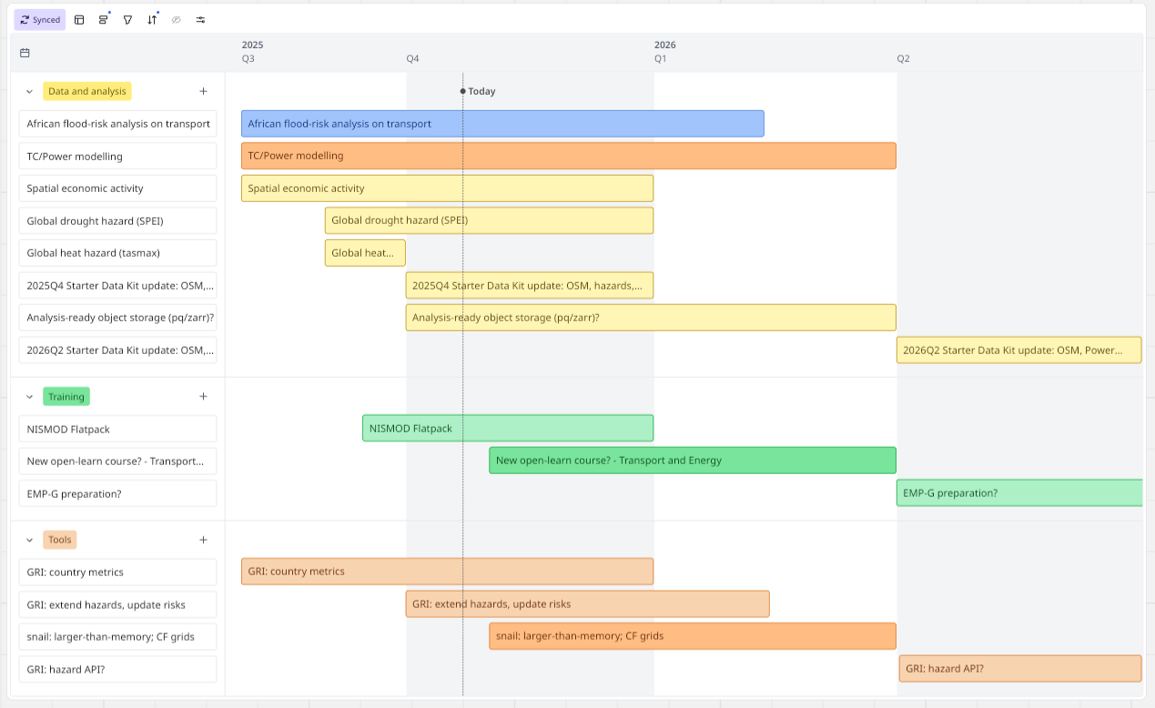

- Gathering Ideas whiteboard session, collecting suggestions on needs, collaboration and improvement ideas, funding opportunities for future work and collaboration projects.
Category | Notes
collaboration idea | Accessibility/ transport resilience with U Strathclyde
collaboration idea | heat extremes and the applications to farming and livestock
collaboration idea | housing the data from data starter kits with CCG's other data kits on AWS S3
collaboration idea | involvement with osemobility project (CCG) on accessibility-based travel demand modelling (Strath/Imperial)
collaboration idea | Possible collaboration with U Strath to include spatial economic activity in Osemobility (Strath- James+Fatima)
collaboration idea | TC downscaling calibrated with Jamaican met data
collaboration idea | Collab with DSKs / Transport Data Commons (validation and verification/harmonisation of data sources)
collaboration idea | Most of the TC track tools fail to capture the natural variability, possible collaboration to improve this
funding opportunity | Next round of Horizon EU?
funding opportunity | potentially ESMAP for energy infrastructure vulnerability mapping - particularly if it could assess the vulnerability of future and planned RE projects in some way
funding opportunity | See horizon clusters on climate energy & mobility
improvement | could the global economic activity mapping project be used to help governments or cities identify potential value added from new projects, to create new future-value taxes to fund projects?
improvement | explicit links to adaptation finance
improvement | API for all the hazards at a point, anywhere
improvement | Inclusion of uncertainty information
improvement | I like the idea of country overviews in GRI, maybe adding stories/comparisons with a global average or a regional average to help create a benchmark to compare a country or asset against
improvement | TC parsing / wind field / downscaling lib
improvement | Generic power systems model for criticality analysis: PyPSA with link to spatially explicit network model
improvement | GRI Risk Viewer: ability to present data and visualisations in a narrative/storytelling way (like Our World in Data)
needs | Complete downscaled rGVA data for economic disruption analysis

15.40-15.55 Capacity building presentation
- Capacity building unit presentation on current and future activities: Open Learn Collection, Bootcamps, energy modelling platform and community, in-country workshops, flatpack and catalyst facility initiative, train the trainer and badges system (Fynn)

15.55-16.00 Final remarks

