Effective Land Governance for Zambia’s Mining Sector: Policy Challenges and Recommendations

**Authors:** Rebecca Clube, Freeman C. Mubanga, Lannette Kambole-Chiti, Nsama M. Chileshe, Jennipher Mwanangombe, Haggai Nyambe, Maggie M. Mwape, Gerald E. Arhin, Muchima Mulunda, Kabwe Mubanga, Yacob Mulugetta, and Julia Tomei.

## Key messages:

* Driven by the rising global demand for critical minerals, an increase in large-scale land acquisition for mining in Zambia is creating economic opportunities but also social risks. These risks are amplified by the country's complex, dual land tenure system.
* This Brief summarises findings from an exploratory study on the intersection of land governance and mining in Zambia. The study used both primary and secondary data, including a policy review, expert interviews, and a case study of a mining-affected community.
* The findings revealed five key challenges, namely increasing conversion of customary to state land tenure; a lack of a standardised procedure for land transactions; limited coordination between key actors; a lack of legally binding resettlement support; and no legal obligation for benefit sharing.
* Overall, there is urgency to address these challenges through amendments in the land and mining frameworks, given the Government’s commitments to rapidly scale up mining activities.

## Introduction and Context

The low-carbon transition requires an adequate and secure supply of various minerals, such as copper, lithium, manganese, and cobalt. These minerals are often labelled as ‘critical’ because they are essential for manufacturing renewable energy components and technologies [1]. According to the International Energy Agency, the demand for critical minerals is projected to triple to reach 35 million tonnes annually by 2040 [2].

Zambia has abundant natural resources, including critical minerals. The mining sector is essential to the Zambian economy, contributing substantially to export earnings, tax revenue, and GDP [1]. Whilst copper has historically dominated the economy, the Government of Zambia has signalled its commitment to expanding the extraction of other minerals, such as graphite, nickel, manganese, and rare earth elements, as reported in the National Critical Minerals Strategy [3].

Scaling up mining exploration and exploitation necessitates increased land access. However, land has competing uses in Zambia, including for agriculture, tourism, conservation, and livelihood activities, and holds diverse economic and cultural values for different groups. Land governance is further complicated by the country’s dual tenure system, which comprises both customary and state land. The 1995 Lands Act [4] introduced a major shift by allowing the conversion of customary land into state tenure, thereby enabling investors to obtain leaseholds, though all land legally remains vested in the President. This liberalisation spurred a surge in large-scale land acquisitions, including by foreign investors. Since then, the policy environment for land governance has evolved through successive policies and laws, but the Lands Act remains the cornerstone legislation (Figure 1). Moreover, **Figure 1** also highlights how the mining framework has undergone a parallel process of development. Notably, there has been a recent renewed effort to scale mining in response to rising global demand for critical minerals.

According to the World Bank (2024), Zambia has the potential to attract investments of up to US$21 billion by 2030, including in the mining sector [5]. These investments will inevitably trigger a further increase in land transactions. Changes in land use, and its ownership arrangements, can create opportunities as well as social, economic, and environmental tensions. Competition between investors and communities has caused displacements and the erosion of social, environmental, and cultural systems [6]. This situation underscores the urgent need for a robust and inclusive land governance framework to equitably manage land investments and ensure all Zambians benefit from the increased global demand for minerals.

***Figure 1:*** Overview of policies and laws governing land in Zambia; the top refers to key land-related policies, whereas the bottom refers to mining-related policies, including the most pertinent environmental laws to the sector (figure by authors).

## Research approach

Based on an exploratory study in Zambia, at the national and local levels, this Brief provides insights into the intersection between land governance and mining. It draws on primary and secondary qualitative data, as follows:

* **Policy and legal review:** an analysis of national policies, strategies, and legislation pertaining to land and mining was conducted to understand the evolution of the policy regime and identify gaps in the land and mining frameworks.
* **Expert interviews:** Semi-structured interviews were carried out with eight experts (including representation from Civil Society Organisations (CSOs), government, and other specialists) to ascertain their views on issues at the intersection of land governance and mining.
* **Case study**: A case study of a community in Serenje District was conducted to provide insights into the local-level challenges associated with land-use change caused by mining. Serenje is known for manganese mining; manganese is a critical mineral of high demand due to the energy transition. Six key informants were interviewed, and two focus group discussions held, one with women and one with men, each with fourteen participants.
* **Dialogue events:** Two workshops were held in Lusaka: one at inception and the other at completion. A variety of stakeholders attended (eg government representatives, CSOs, independent experts) for discussion and feedback.

## Findings

Five challenges were identified relating to the intersection of land-use governance and mining (**Figure 2**); these are presented in the following sub-sections. The challenges emerged from analysis of the national level – both from the policy review and expert interviews. They are supplemented by insights into how these challenges manifest at the community level through findings from the case study of Serenje. Extracts from the interviews are included for illustrative purposes.

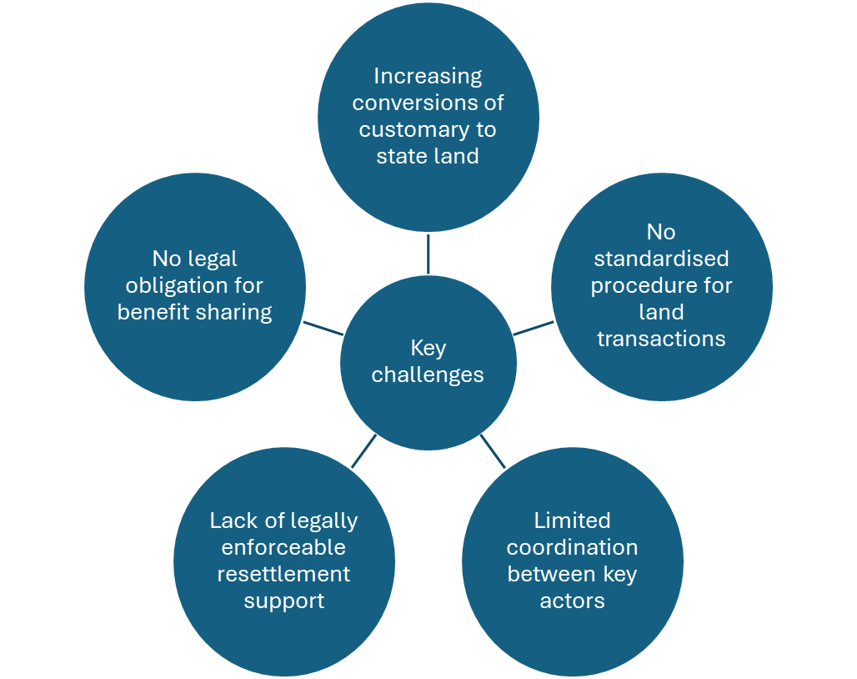

**Figure 2**: Overview of the key challenges identified in the primary and secondary data (figure by authors).

## Increasing Conversions of Customary to State Land

*“The problem is that this conversion process is one-directional, there is no legal provision to revert state land back to customary tenure.”* (expert interview)

Zambia’s land framework encompasses both customary and state tenure arrangements; the former is primarily administered by traditional authorities, whereas the latter is administered by the government. The Lands Act [4] triggered a major shift in the land governance regime, as it enabled the conversion of customary land to state tenure. A conversion requires the Chief’s consent, who should also consult with community members and obtain approvals from the Commissioner of Lands and other relevant local authorities. The expert interviews highlighted the common challenge of land being converted without adequate consultation. Individuals who have historically lived on the land may have no documentation, causing land rights issues. In Serenje, poor recordkeeping and a lack of demarcation of lands was also reported. As such, participants described land being sold without community consent, and cases where the same piece of land was sold multiple times to different investors. These issues cause tenure insecurity and community conflicts.

The findings revealed concerns that increased external interest in land for mining has resulted in significant areas of land being converted from customary to state tenure. Nonetheless, it is unclear how much land has already been converted, although estimates suggest that anywhere between 65–90% of Zambia is under customary arrangements. Weak record-keeping compounds the problem, although a pilot land audit is underway, supported by the European Union￼. The rapid increase in conversions has raised alarm because they are widely considered irreversible. For example, if an investor buys the land but fails to use it for the intended purposes, there appears to be no mechanism to revert the land to its original customary tenure. Similarly, uncertainty surrounds what happens when a leasehold granted on state land expires (99 years is standard). In practice, customary rights are typically viewed as extinguished once a lease is granted. Nonetheless, these ambiguities have prompted calls for the Lands Act to be updated to provide clarity and strengthen safeguards.

## No standardised procedure for land transactions

*“...it presents challenges in a way, because we have so many chiefs. And there's no standardisation when it comes to customary tenure.” (*expert interview*)*

Zambia lacks an effective legal framework for the sale and purchase of land, particularly customary land. Key documents, such as the Land Administrative Circular No. 1 of 1985 and the Lands Act [4, 6] are fragmented and increasingly outdated. The Lands Act is heavily skewed towards state lands, yet the land in high demand for mining purposes was considered to mainly be on customary land – this classification of land is dominant in Zambia. Even the National Lands Policy [6] highlights that laws are outdated and contain gaps regarding the alienation of land.

Customary land governance is largely informal, and open to the discretion of Chiefs who “*wield significant power*” (expert interview). These traditional leaders often manage customary transactions with investors, without guidelines, transparency, or understanding of land value. As such, the findings point to large inconsistencies across the country as to how customary land transactions take place. Whilst investors must obtain consent from the traditional leader, often communities are not meaningfully consulted, which creates tenure insecurity for rural populations, but also heightens investment risk for investors as conflicts frequently arise. The procedures for land transactions were deemed to be unclear, slow, and cumbersome. Investor guidance is also limited; the Zambia Development Agency (ZDA) is tasked with supporting investors to acquire land, but it is unclear in what form this support is provided, although an Investor's Guide is available on its website, which outlines some general information on land-based investments [7].

## Limited harmonisation and coordination between key actors

*“One of the key issues we face is the lack of harmonisation between different laws. Currently, various ministries operate under separate laws that are often in conflict with one another."* (expert interview)

Land-use governance requires effective institutional coordination, including with informal actors such as traditional authorities. This need will become even more pressing as mining activities expand. Nonetheless, the findings point to persistent coordination challenges, which may stem from shortcomings in the legal framework (eg conflicts between mining and land laws, inadequate designation of roles and responsibilities, lack of coordination mechanisms).

Both at the national level, and in Serenje district, a common concern was that there are ongoing tensions between land rights and sub-surface rights, with limited coordination between the two approvals processes. The Ministry of Mines and Mineral Development (MMMD) is responsible for granting mining rights (ie for exploration or mining of a particular resource in a designated area) per the Minerals Regulation Commission Act of 2024 [8], whereas the Ministry of Lands and Natural Resources (MLNR) is responsible for allocating surface rights for state land through the Lands Act. In practice, there is limited harmonisation between the processes; the study revealed instances where investors initially successfully obtained mining licences and then came to the area expecting the land rights to be automatically granted on this basis. Whilst sub-surface rights typically take precedent over surface rights, the lack of coordination in the system was suggested to increase community conflicts, but also the risk of corruption by different actors, including chiefs, mining companies, and government officials due to power imbalances and information asymmetries.

In addition to the MLNR and MMMD, coordination with other institutions is essential, particularly with the Zambia Environmental Management Agency (ZEMA) (eg relating to Environmental Impact Assessment processes) and the ZDA (eg by supporting foreign investors to acquire land). However, effective coordination and communication between institutions is lacking, which has caused various practical challenges. For example, there have been cases where the MMMD has granted licences for exploration or extraction on ecologically important land, whilst ZEMA has refused to grant environmental licences. Consequently, high-profile disputes and legal cases have emerged from conflicting ministerial decisions, such as regarding the Lower Zambezi National Park [9].

## Lack of legally enforceable resettlement support

*“Communities are being displaced, and we need a legal framework to address these issues, protect community concerns, and ensure their rights are safeguarded. As far as I know, there is no such law, and I am not aware of any formal efforts to develop one.” (*expert interview*)*

The findings revealed that mining-induced displacements are commonplace, causing significant disruption and social upheaval for communities. Experts, as well as informants and community members in Serenje, confirmed the severity of this challenge. Often, communities are forced to move from their homes and abandon their livelihoods without being consulted, as deals have already been made between mining companies and chiefs. Communities may receive insignificant compensation, or the traditional authority may keep any proceeds from sales. Communities are often powerless in these situations given they are economically disadvantaged and “*unaware of their rights*” (community member). The fact that key laws, such as the Lands Act [4], are “*silent*” (expert interview) on resettlement was frequently raised as a major flaw in the framework.

In the absence of legislation, the National Resettlement Policy of 2015 [10] sought to provide guidance on resettlement issues, including for involuntary investment-related displacement, specifying that resettlement support and compensation should be provided before a development project starts. However, it is not sector specific and refers instead to issues such as transferring vulnerable and displaced persons to underdeveloped agricultural lands, rather than providing explicit guidance for mining companies. An update to this policy in 2024 similarly lacks sector-specific guidance and fails to include the MMMD in the implementation plan. Hence, the update does not appear to fully rectify the original policy’s shortcomings. Regardless, these documents are policy, rather than legislation, so they lack legal basis. The findings overwhelmingly point to the need for a legally enforceable mechanism to protect and compensate communities.

## No legal obligation for benefit-sharing

*“Currently, most revenue goes to central government, leaving little for local development... There should be a structured revenue-sharing model where local communities directly benefit from mining activities."* (Local informant interview, Serenje)

Under the Constitution, there is an underlying principle that Zambians should benefit from the country’s land and natural resources[1]. However, neither the mining nor the land governance frameworks have clear, specific, and enforceable mechanisms to ensure local communities receive benefits from mining projects. The fact that mining companies are not legally obliged to support or compensate affected communities was deemed a major oversight in the legal framework amongst interviewees at the national and local levels. Whilst royalties and other taxes are centrally collected by the Government, there seemed to be an overall frustration that locals do not directly benefit from the proceeds of mining. Often communities lose their livelihoods (eg in agriculture), whilst being exposed to negative – and often severe – health and environmental impacts. In Serenje, even when community members were employed by the mines, the jobs were associated with hazardous conditions and low wages.

Since there is no legal provision for benefit sharing, there is reliance on corporate social responsibility (CSR) schemes. These schemes are also not mandatory in Zambia, as they are in other countries, such as South Africa. The findings suggest that even when they do exist, they were not always effective. For example, interviewees in Serenje argued that CSR is often symbolic, and is used as a “*public relations tool*” by mining companies, rather than to genuinely support community needs. There was a prevailing view that the government should establish a legally binding benefit sharing mechanism that supports affected communities.

## Policy recommendations

These findings point to the following recommendations:

* **Revise the legal framework:** Overall, the findings indicate that the current land governance framework, particularly the Lands Act, requires updates to reduce ambiguities and provide much-needed detail. Crucially, the rights of communities need to be legally determined to reduce tenure insecurity and conflicts, especially regarding conversions to state land. Updates to the land framework should be harmonised with the mining framework for consistency, overturning current tensions (eg between mining licences and land permissions).
* **Develop an interministerial coordination strategy**: Given ongoing coordination challenges, there is a need to establish a formal interministerial strategy to ensure effective collaboration between key ministries and departments, such as the MMMD, MLNR, and ZEMA. This could involve the formation of an cross-ministerial steering committee to oversee issues requiring coherence and coordination, such as the various licensing procedures. It may also involve representation from traditional authorities, to reduce conflicts between customary and state land governance.
* **Create guidelines for traditional authorities:** Since traditional leaders hold significant discretionary authority regarding customary land governance, including relating to conversions and transactions, standardising this process could help to reduce corruption, prevent investor confusion, and improve transparency. There is a need for research into the optimal approach, but in the short term, an initial step could be to develop best practice guidelines for Chiefs to encourage traditional authorities to consistently and transparently manage land transactions.
* **Establish a legally binding resettlement mechanism:** Despite updates to the Resettlement Policy, these amendments still lack specificity when it comes to mining-induced displacements. There is an opportunity to enact legislation to ensure resettlement support for displaced individuals or households is mandatory, with clear guidance regarding monetary compensation as well as non-financial support. These legal safeguards are essential to ensure all community members are protected and less exposed to predatory practices by powerful investors.
* **Establish a legally binding benefit sharing mechanism**: Voluntary CSR in Zambia has failed to provide equitable and transformative development outcomes. Therefore, policymakers should explore the potential to amend the current mining legislation, or establish a standalone statutory instrument, so mining companies are required to make mandatory financial contributes to affected communities. This instrument could take various forms. For instance, it could ensure a percentage of mining companies’ revenues is allocated to a dedicated, locally managed fund that supports community development, or it could require direct cash transfers to affected community members.

## References

[1] Cervantes Barron, K., Clube, R. K., Chabala, R., Matokwani, M., & Chikwamo, M. J. (2024). Value addition for who? Challenges to local participation in downstream critical mineral ventures in Zambia. The Extractive Industries and Society, 20, 101544. doi: <https://doi.org/10.1016/j.exis.2024.101554> [Accessed15 April 2025]

[2] International Energy Agency (2025). Critical Minerals – A New Frontier for Global Energy Security [Online]. Available at: <https://www.iea.org/topics/critical-minerals> [Accessed 24 April 2025]

[3] Republic of Zambia, Ministry of Mines and Minerals Development (2024). National Critical Minerals Strategy 2024 – 2028. [Online] Available at: <https://www.mmmd.gov.zm/wp-content/uploads/2024/09/1-National-Critical-Minerals-Strategy-2024-%E2%80%93-2028-Booklet-August-27-2024.pdf> [Accessed 1 September 2025].

[4] Republic of Zambia (1995). *Lands Act, 1995. Chapter 184 of the Laws of Zambia*. [Online] Available at: <https://www.parliament.gov.zm/sites/default/files/documents/acts/Lands%20Act.pdf> [Accessed 15 April 2025]

[5] World Bank (2024). Zambia: Country Private Sector Diagnostic – Executive Summary. [Online] Available at: <https://documents1.worldbank.org/curated/en/099822401202575080/pdf/IDU-2fa78530-716a-439b-ad04-87b781316649.pdf> [Accessed 13 May 2025].

[6] Republic of Zambia (2021). National Lands Policy. [Online] Available at: <https://faolex.fao.org/docs/pdf/zam219882.pdf> [Accessed 21 June 2025]

[7] Zambia Development Agency (ZDA). (2020). Zambia’s Investors Guide Handbook*.* Lusaka: ZDA. [Online]. Available at: <https://www.zda.org.zm/wp-content/uploads/2020/12/ZDA-Investors-Guide-.pdf> [Accessed 29 May 2025]

[8] Republic of Zambia (2024). The Minerals Regulation Commission Act, 2024*.* [Online] Available at: <https://www.parliament.gov.zm/sites/default/files/documents/acts/Act%20No.%2014%20of%202024%20The%20Mineral%20Regulation%20Commission.pdf> [Accessed 29 May 2025]

[9] EJ Atlas (2022). Kangaluwi Copper Mine in the Lower Zambezi National Park, Zambia. [Online] Available at: <https://ejatlas.org/print/proposed-kangaluwi-copper-mine-in-the-lower-zambezi> [Accessed 10 June 2025]

[10] Republic of Zambia (2015). National Resettlement Policy. [Online] Available at: <https://www.refworld.org/legal/decreees/natlegbod/2015/en/120370> [Accessed: 21 June 2025].

[11] Republic of Zambia (2016). Constitution of Zambia (Amendment) Act No. 2 of 2016. [Online] Available at: <https://www.parliament.gov.zm/sites/default/files/documents/amendment_act/Constitution%20of%20Zambia%20%20(Amendment),%202016-Act%20No.%202_0.pdf> [Accessed 23 September 2025]

**Author Information**

* + Dr Rebecca Clube, UCL, Institute for Sustainable Resources (ISR).
  + Freeman C. Mubanga (Centre for Environmental Justice (CEJ), Head of Research and Studies).
  + Haggai Nyambe (CEJ, Monitoring and Evaluation Specialist).
  + Nsama M. Chileshe (CEJ, Programmes Liaison Consultant).
  + Jennipher Mwanangombe (CEJ, Programmes Coordinator – Extractive Industries & Environmental Protection).
  + Maggie M. Mwape (CEJ, Executive Director).
  + Dr Lannette Kambole-Chiti, Chief Executive Officer, Center for Environment Energy and Climate Action (CEECA).
  + Dr Gerald Arhin, UCL Department of Science Technology Engineering and Public Policy (STEaPP).
  + Muchima Mulunda, University of Zambia.
  + Dr Kabwe Harnadih Mubanga, University of Zambia, Geographical Sciences, Environment and Planning Department
  + Professor Yacob Mulugetta, UCL STEaPP.
  + Professor Julia Tomei, UCL ISR.

**Acknowledgements**

This material has been produced with support from the Climate Compatible Growth (CCG) programme, which brings together leading research organisations and is led out of the STEER centre, Loughborough University. CCG is funded by UK aid from the UK government. However, the views expressed herein do not necessarily reflect the UK government's official policies.

**Recommended citation**

Clube, R., Mubanga, F. C., Kambole-Chiti, L., Chileshe, N. M., Mwanangombe, J., Nyambe, H., Mwape, M. M., Arhin, G. E., Mulunda, M., Mubanga, K., Mulugetta, Y., & Tomei, J. (2025). Effective Land Governance for Zambia’s Mining Sector: Policy Challenges and Recommendations. Climate Compatible Growth.

1. The Constitution of Zambia, Amendment Act No. 2 of 2016, Article 253, Section 1 states that ‘Land shall be held, used and managed in accordance with the following principles [...] (h) investments in land to also benefit local communities and their economy’ [11].